CS 255 System Design Document

UML Diagrams

UML Use Case Diagram
Actors: Student, Instructor, Administrator
Use Cases:
1. Register Account: Student creates a new profile with personal data.
2. Schedule Lesson: Student selects an open slot from an instructor's availability.
3. Manage Availability: Instructor publishes dates/times they are open to teach.
4. Process Payment: System securely charges student's payment method for the booked lesson.
5. Generate Analytics Reports: Administrator reviews metrics on overall booking frequency and
revenue.
Relationships: Student initiates Register Account, Schedule Lesson, and triggers Process
Payment. Instructor initiates Manage Availability. Administrator initiates Generate Analytics Reports

The use case diagram illustrates the functional boundaries of the DriverPass platform across three primary actors: Students, Instructors, and Administrators.
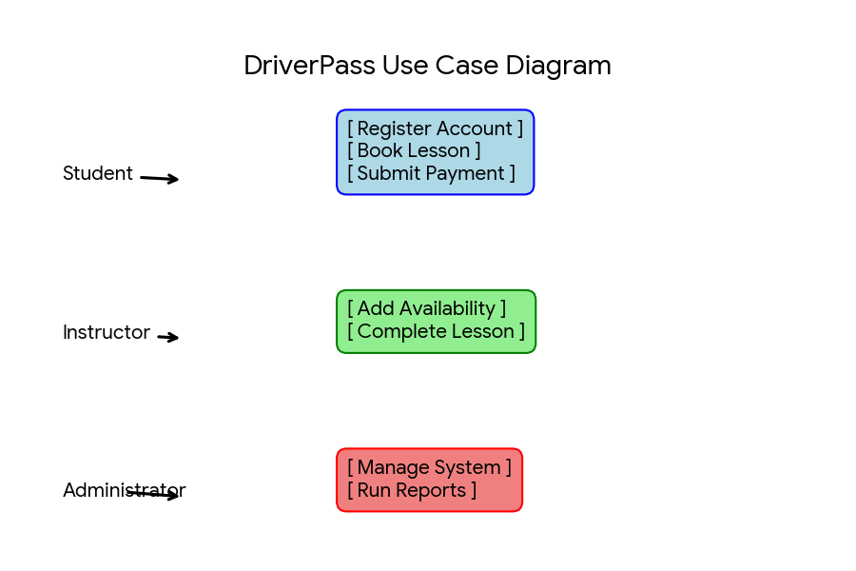

UML Activity Diagrams
Activity Diagram 1: Schedule a Driving Lesson
Below are the step-by-step process workflows for the scheduling and payment modules.
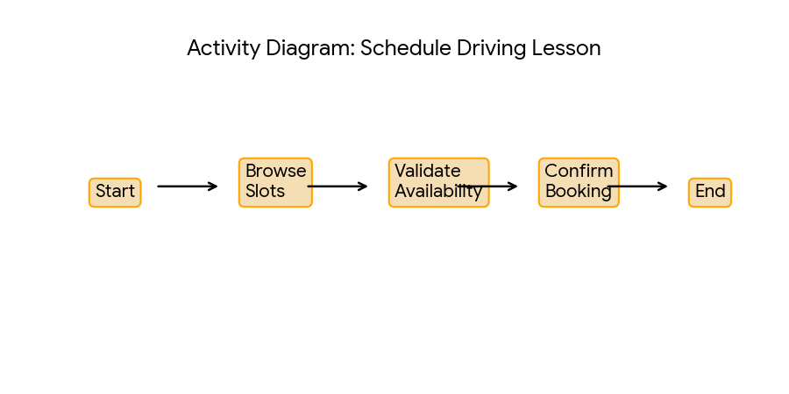

Activity Diagram 2: Process Lesson Payment
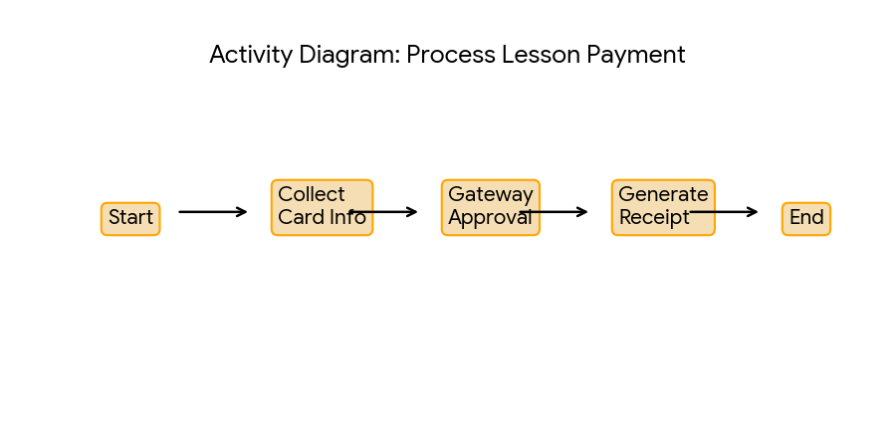

UML Sequence Diagram
This sequence diagram visualizes the interactive data lifecycle between system layers during slot selection.

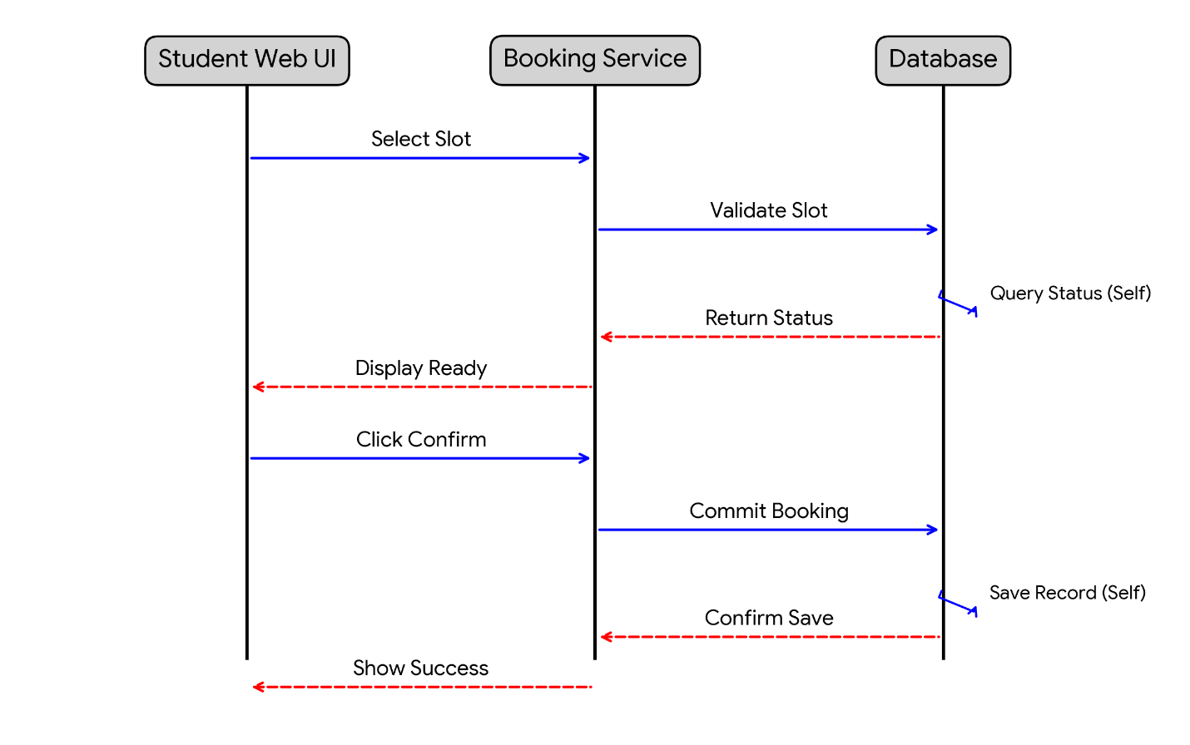

UML Class Diagram
- Student Class: studentID (Int), name (String), email (String), phone (String).
- Instructor Class: instructorID (Int), name (String), certificationNum (String).
- Lesson Class: lessonID (Int), dateTime (DateTime), status (String).
- Payment Class: paymentID (Int), amount (Decimal), transactionStatus (String).

Technical Requirements
- Hardware Infrastructure: Cloud nodes configured with 8GB RAM and 4 vCPUs behind a load balancer.
- Software Environment: Ubuntu Server Linux OS paired with a PostgreSQL relational database system.
- Tools: Docker containers to mirror local production environments and GitHub Actions for CI/CD automation.

